Julien Bacon
Julien.bacon@Neptronic.com
Zephyr – Workspace Setup

Table of Contents
Introduction 1
Setting up the Development Environment 2
Zephyr Workspace 2
VS Code Setup 3
Adding a Project to the Workspace 4
Detailing the Files that Make It Works 5
The VS Code Workspace 5
The Project’s Settings File 5
Merging 7
Automatic Merge 7
Merging with Conflicts 8
Continuous Integration/Continuous Development (CI/CD) 9
Revisions 10

Introduction
The present document is a quick guide for helping anyone to setup and use their Zephyr RTOS workspace on their PC.
The first section is a step-by-step guide on how to setup the development environment. This includes the Zephyr workspace, VS Code and extensions setup.
The second section list and describe the workspace variables and setup, the projects scripts, and VS Code settings. It will also describe how to add a project tor the workspace.
The third section details the VS Code workspace, task, launch and settings files. An overview of the scripts inside a project is also done.
The fourth section explains how to debug an application in VS Code.

Setting up the Development Environment
This section will guide you in setting up your development environment. First it will guide you in setting up the zephyr workspace. Finally, it will guide you in setting up you VS Code.

Zephyr Workspace
To create your Zephyr workspace, do the following:
- Create a folder that will contain the zephyr workspace. For example, create the zephyrWorkspace folder in your Documents directory.
- Follow the instructions of Zephyr RTOS Getting Started Guide.
  - Make sure to select the Windows tabs in the instructions.
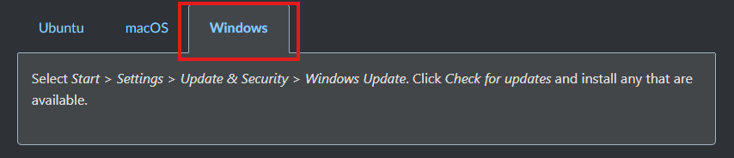
  - In the Install Dependencies section don’t automatically follow the links to manually install them. Follow the instructions below the list.
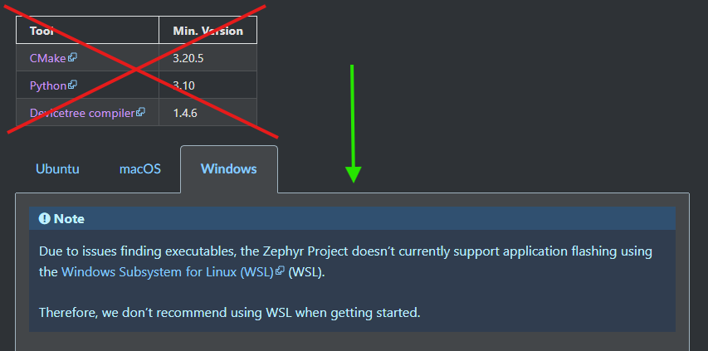
  - Make sure to follow the Install within virtual environment instructions.
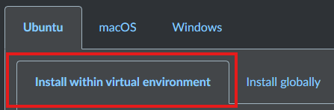

VS Code Setup
To Setup VS Code simply do the following:
- Install STM32CubeProgrammer
- Install STM32CubeIDE (you may need to flash a demo project to trigger Windows firewall rules update)
- Install VS Code.
- Install the following extensions in VS Code
  - C/C++ extensions.
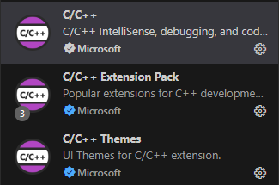
  - CMake extensions.
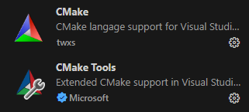
  - Debugging Extensions.
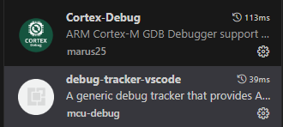
  - Formatting Extension.
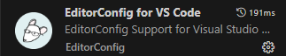
  - Kconfig Extension.
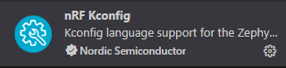
  - Devicetree Extension.
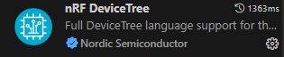
  - Workspace Terminal Extension.
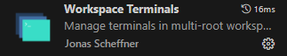
  - RTOS Views Extension.
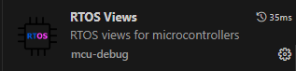
  - Serial Terminal Extension (optional, if you prefer Putty or another one).
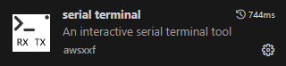
- Create the VS Code workspace file.
  - Create a file named zephyr.code-workspace in the zephyrWorkspace directory (copy the one from the directory of this document).
  - Add the following to it:
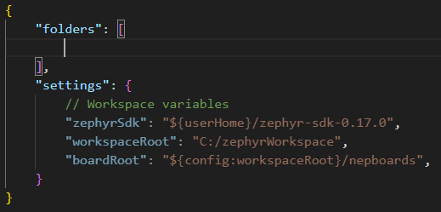
  - Make sure to update the workspaceRoot, in the settings section, with the correct path.
- Create a folder in the workspace root name apps or rename the existing app folder to apps.

Adding a Project to the Workspace
Projects will be added inside of the apps directory. Here you can either recreate the structure from GitLab or a completely different one or have a flat directory tree.
To add a project to the workspace, simply do the following:
- Clone the project anywhere inside the apps directory.
- Add it to the VS Code workspace file as follow. Make sure to use the appropriate information.
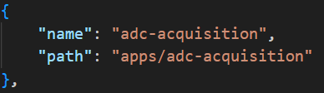

If you clone directly from VS Code you will have the possibility to add the new cloned repo to the workspace.

Detailing the Files that Make It Works
This section details all the file, either in the workspace or in the projects that make everything works.

The VS Code Workspace
This file is use by VS Code to manage a workspace. It allows to open multiple projects in a single VS Code window. It can also be used to define workspace wide settings, tasks, etc.
The file is constructed as follows:
- The folders section is a list/array of all the folder/project you may want to have access from the VS Code file explorer. Each entry in the list has the following properties:
  - The name property is the name under which the folder/project will be displayed in the VS Code file explorer.
  - The path property is the path to the folder to use.
- A tasks section can be added to define workspace tasks, but we are not using it.
- A launch section can be added to define debug configuration, but we are not using it.
- The settings section is used to define either VS Code, extension settings or user define variables. In our case we have define 3 user variables. Those variables are used in each projects tasks and launch files.
  - The zephyrSdk variable is used to point to the zephyr SDK (toolchain, etc.).
  - The workspaceRoot variable is used to point to the workspace root.
  - The boardRoot variable is used to point to the Neptronic board definitions.

The West Config File
This file tells west (the Zephyr build tool) what application to build. It’s located in .west folder of the workspace directory. This file gets automatically updated by the projects different scripts.

The Project’s Settings File
This file contains the VS Code settings for the project. This file is in the .vscode folder of each project and contains the settings:
- The cmake.configureOnOpen setting is used to stop the CMake extensions to as to be configured.
- The C_Cpp.default.compilerPath setting is used by the C/C++ extensions to know where the compiler executable is located.
- The C_Cpp.default.compileCommands setting is used by C/C++ extension to build the code structure database for things like code completion, etc.

The Project’s Launch File
This file contains the debugging configuration of the project. The file is in the .vscode folder of each project and contains the following configurations:
- The JLink GDB server configuration is used to launch a debug session with a JLink debugger on the Segger GDB server.
- The OpenOCD configuration is used to launch a debug session with a debugger compatible with the OpenOCD server.
- The STLink GDB server configuration is used to launch a debug session with a STLink debugger on the Zephyr GDB server.
These configurations have important information that needs to be updated if your projects use a different board or microcontroller.
- The svdFile setting is used to point to your board microcontroller .svd file. To ensure compatibility with everyone’s development environment, please make sure to use the user defined variables.
- For the OpenOCD configuration, the configFiles is used to point to your board OpenOCD configuration file. To ensure compatibility with everyone’s development environment, please make sure to use the user defined variables.

The Project’s Tasks File
This file contains different tasks that can be used to execute actions either through the command functionality of VS Code or while launch a debug session. The following tasks are included:
- The Zephyr Build task is used to execute a build operation in automatic pristine mode. This build operation will try to figure out by itself if a pristine build is needed.
- The Zephyr Pristine Build is used to execute a pristine build (clean followed by build) operation.
The normal build task is already used in the launch configuration. To use the tasks with the command functionality of VS Code, simply use the ctrl+p shortcut and select the Tasks: Run Task command, then select the task you want to run.

The Project’s Build Script
This script is used to build your project. To be able to run this script the python virtual environment needs to be activated and at least one update should have been done. The build options can be controlled with different flags and arguments that can passed to the script. Those options are as follow:
- The -auto flag if present allows you to build in automatic pristine mode. Otherwise, the build will be done in pristine mode.
- The -update flag if present will execute a west update command before building the project.
- The -board <board> argument can be used to specify board other than the project default board.

The Project’s Configure Script
This script is used to launch the Zephyr configuration “UI” tool. To be able to run this script the python environment needs to be activated and at least one build should have been run.
Although we don’t recommend using the UI tool to create or update your project’s configuration, this tool can be useful to search for configuration symbols and look at their documentation.

The Project’s Update Script
This script is used to update the project dependencies. When starting to work on a new or different project, at least one update should be made to make sure that all the dependencies are clone and at the right revision.

Running a Debug Session
This section will describe how to run a debug session on VS Code.

Launching the Debug Session
To launch a debug session simply do the following:
- Select the Debug Tab on VS Code.
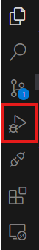
- Selection the appropriate debug configuration and click the play button.
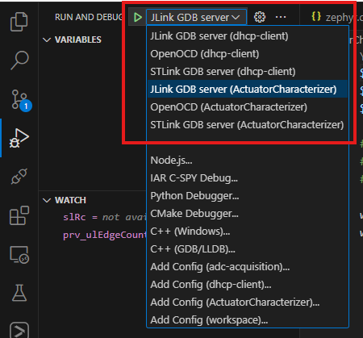
- By default, the debug configurations are set to stop at the beginning of the main. But sometimes it may stop in the start up file. If it’s the case, simply use the continue control (F5) to get to the main.

Debugging
While debugging you will have access to all the standard debugging tools and utilities
- The debugging controls (top right of VS Code window).
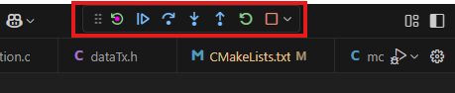
- The breakpoints (debugging panel).
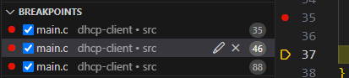
- The Variables window (debugging panel).
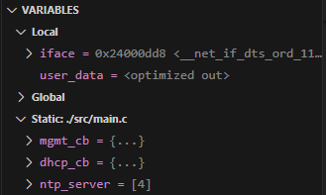
- The Watch window (debugging panel).
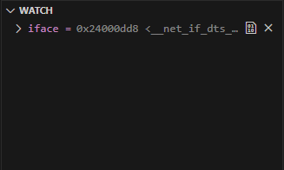

- The Call Stack window (debugging panel).
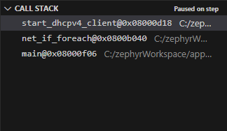
- The Live Watch window (debugging panel).
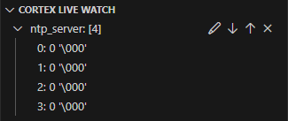
- The XRTOS window (bottom panel).
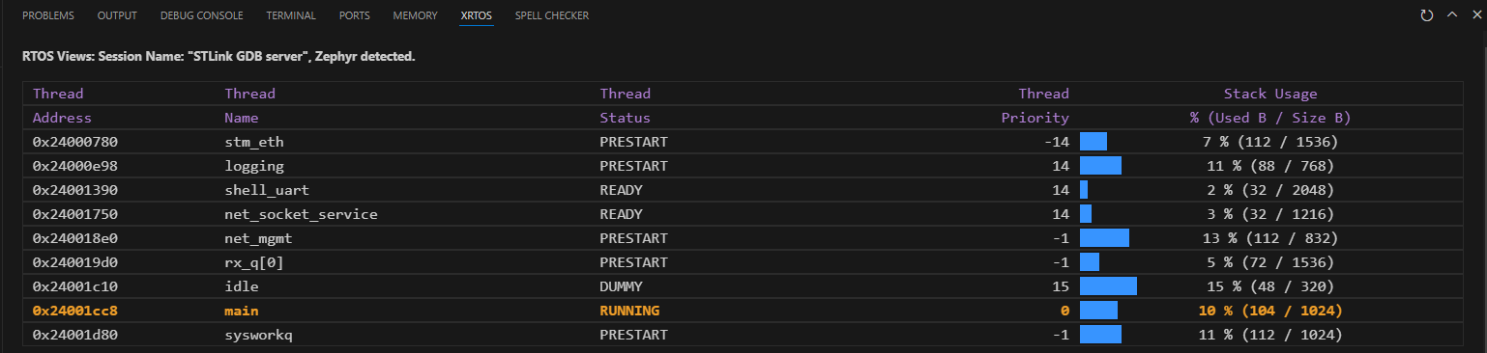

The Serial Terminal Extension
If you opt to use the serial terminal extension on VS Code, here is how to use it.
- Select the serial port resource manager from the left panel.

- Select the desired serial port and configuration.
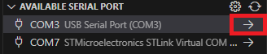
- Then the extension will open a terminal in the bottom panel with the serial connection.

Revisions

Revision number | Modification date | Modification | Author
1.00.00 | 2024-01-07 | - Initial draft. | Julien Bacon

